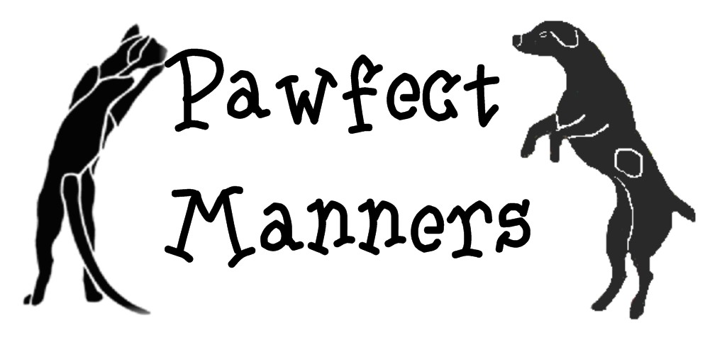  Instructor: Judy Seils  Phone: 281-440-6818  E-mail: judy@pawfectmanners.com  www.pawfectmanners.com | - Puppy/Kitten Manners 101  - Clicker Intro  - Canine Manners 101  - Canine Manners 201 (prereq. Clicker 101)  - Clicker Fun (prereq. Clicker 101)  - Private Class  - Feline Manners 101

Owner’s Name
Address
City, State Zip
Phone Numbers | (Hm) (Wk) (Cell)
Email
Vet’s Name/Phone
Referred by:
Dog’s Name |  | Breed | Date of Birth | Sex M / F  Neutered Y / N
At what age did you acquire this pet? From whom?
Why did you choose this pet? Why this breed?
What percent of time is your pet: inside __________% vs. outside __________%
What is your purpose of keeping a pet?
Describe the games your family plays with your pet?

How does your pet act around other animals?

How does your pet act around people?

Previous experience with dogs/cats?

What are your training goals?
Any specific problems to solve?

WAIVER, ASSUMPTION OF RISK AND AGREEMENT TO HOLD HARMLESS

I understand that participation in dog training class is not without risk to myself, any family members or guests who might attend, and to my dog.

Knowing this, I hereby waive and release Pawfect Manners, agents, trainers and the owners of the property where classes/practices are held from any and all liability of any nature, for injury or damage suffered as a result of my participation in any class or practice lesson, including any damage or injury resulting from the action of any person or dog, or for any accident occurring on the premises or its surroundings. I agree to accept full responsibility for my actions, those of my family or guests and of my dog.

SIGNED: DATED:

Make checks payable to: Judy Seils

Please mail this completed form, the enrollment fee and a copy of your dog’s current vaccinations to:
Judy Seils
7703 Seton Lake Dr. #612
Houston, TX 77086

Instructor: Judy Seils  Phone: 281-440-6818  E-mail: judy@pawfectmanners.com  www.pawfectmanners.com | - Puppy/Kitten Manners 101  - Clicker Intro  - Canine Manners 101  - Canine Manners 201 (prereq. Clicker 101)  - Clicker Fun (prereq. Clicker 101)  - Private Class  - Feline Manners 101

Video/Photograph Release Consent

Please read and complete this form. Return it with your class application.

I, _____________________________, release video/photographs taken of my pet to be used by Pawfect Manners for educational purposes. This may include company newsletters, online media (FaceBook, Pawfectmanners.com website), and/or staff/client training videos.

I understand that none of my personal information will be published with any photo/video taken and every effort will be made to protect my privacy.

- _________ I consent to the use of my pet’s name in association with this photo/video.
- _________ I DO NOT consent to the use of my pet’s name in association with this photo/video. I understand that a generic name may be used instead of my pet’s real name.
*****
- ________ I DO NOT give Pawfect Manners permission to use my pet’s video/photographs.
*****

______________________________________ _______________
Owner Signature Date

Instructor: Judy Seils

Phone: 281-440-6818
E-mail: judy@pawfectmanners.com
www.pawfectmanners.com

The owner of each pet is required to show proof of current vaccinations for:
For dogs: RABIES DHPPC BORDETELLA
For cats: Rabies FVRCP

Group classes are limited to the first 5 students enrolled.

- The classes are adult oriented. Training requires dexterity, timing and an understanding of animal behavior. It can be a daunting task, even for adults. If you plan to have your child (under 16) train the dog in class, please contact me prior to starting group class, so we can thoroughly discuss your options.
- Please, no contact between dogs or cats. If your pet is sick, do not bring it - owners should come without the pet.
- Bitches in season should come in britches.

Dog training is NOT
just an event

~It’s a lifestyle ~
IMPORTANT REMINDERS

- Your check will not be deposited until after the first class. If you need to cancel the training, your payment can be returned to you at any time up to that point.
- Class will start on time. Please don't be late, it is very disruptive to the other students.
- Vaccinations must be current.
- Come to class 15 minutes early to give your dog
an opportunity to relieve in the doggy toilet area.
- Please, always clean-up after your pet.
- In case of cancellation, I will try to contact you at least one hour prior to class.
- We will train you how to train your pet. Your success will be determined by how consistently you practice the techniques.
- Makeup lessons are available, call for an appointment.

PLEASE NOTE:
Classes are held at Kleinbrook Animal Hospital at the corner of Bammel N. Houston Rd. and Champion Forest Dr. It is located a little over a mile north of Beltway 8 on Bammel.

Kleinbrook Animal Hospital
2202 Bammel N. Houston Rd.
Houston, Tx 77066
(281) 444-8387

If you have any questions,
please contact:
Judy Seils
281-440-6818
E-mail: judy@pawfectmanners.com

www.pawfectmanners.com

*What equipment do I bring?*

Use whatever equipment that suits you and your dog best and gets the best result, in the most humane manner. I suggest using the PREMIER, BUCKLE COLLAR or the HEAD HALTERS. Whatever you choose to use, the equipment WILL NOT TRAIN THE DOG FOR YOU. Collars and leashes are merely tools to help you train your dog. So don’t expect miracles from your equipment - you will make the miracles happen with your training.

~TREATS~

Please bring to class:

Please wear a fanny pack to class every week. This makes training much easier.

Bring training treats. Please only bring soft training treats that can easily be swallowed.

Bring your clicker.

Suggestions: I recommend “Natural Balance,” it is a dog food that comes in a ‘log/sausage’ roll. You can purchase it at PetCo. Slice the roll into thin patties and freeze them in zip lock baggies. Then you can pull out what you need for training and refreeze when you are done. Hot dogs and inexpensive meats can be cut thinly and sprinkled lightly with garlic powder, then microwave until dried out. Pet stores carry many soft training treats.

Do not feed your dog prior to class.

~ LEASHES ~
Please bring to class:

Please bring a 6' leash. Leather, Mountain rope, Nylon or Cotton webbing. It should be stout, but soft enough to not cut into your hand should the dog suddenly lunge. DO NOT BRING THE DOG ON A RETRACTABLE LEASH!

A 30 to 50 feet long line. This long line should always be used when working in unfenced places. You can purchase a cotton webbing long line or make your own.

Please do not bring:
Chain leashes are not appropriate - they are not comfortable to hold and, if wrapped around your
hand or the dogs leg, can inflict serious damage.

Do not trust any leash that has been chewed on.

Flexi leads do not work well for general training. They are very cumbersome for class work.

~ COLLARS ~

A martingale collar is a flat nylon collar with the capability of tightening up on a limited basis. When fitted correctly, the dog cannot slip out of this collar. This is nice for dogs, like Labradors, that have a neck that is almost as large as their heads. (It is not intended to choke the dog, like a choke chain.)

A buckle collar that is well-fitted made of leather or nylon.

Head halters are built to work like a horse halter. Like a horse halter, it is based on the premise that if you control the head, you control the rest of the body. They are effective at gaining control of the overly rowdy or obsessive pulling dogs.

~Please do not bring~

Choke collars, because as the name suggests, this collar is used to administer a correction to the dog by constricting the neck with a choking action.

The pinch collar acts by painfully pinching the skin around the dog’s neck when it is tightened.

A chest harness is great for teaching the dog to pull, but not recommended for general training (unless the dog has a neck or head injury).

